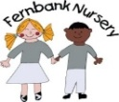Weekly Activities Report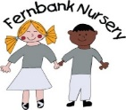
Please see below planned activities for the children for the forthcoming week
W/C 20/01/20
2-3 Years
Kathy and Dawn's Rainbow group
This half term we will be learning about winter and arctic animals as well as learning nursery rhymes.
We will be trying something new to develop our parent partnership with regards to learning. We will be sending home nursery rhyme activity packs for you to do with your child at home. Please then email pictures of your child doing them for us to display on our shared learning with parents board.
Next week we will be;
- Dressing teddy and naming the different clothes items
- Mixing blue and white paint to make winter pictures
- Making snowmen pictures
- Making coconut igloos
- Moving around like different animals

Notes for parent's/carers;
- Please email/bring things into nursery that children have achieved at home, have shown a particular interest in or have enjoyed at the weekend/in the holidays. This helps us to share your child's learning and enhance our activities and areas in the nursery.
- Fernbank library - If you want your child to choose a book and swap it each week at our library please bring in a book bag or purchase one from ourselves for £1.50. Please ask a member of staff for further details.

