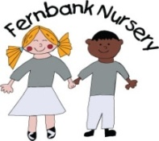 Weekly Newsletter w/c 19/10/20
Below are bubbles that your child is in and activities they will be joining in with next week. Please keep an eye out on evidence me for shared observations and if you have any home learning that you would like to share with us we would love to see it.
Bubble 1 (9-12am, 12-3pm sessions) - Farheen looks after these children. Next week children will be;
- Making our own play dough
- Scissor control activity
- Farm animal small world play. What noises so the farm animals make?
Bubble 2 (9-2pm and 8.45-2.45pm sessions) Rachael looks after these children. Next week children will be;
- Making a pumpkin stamping picture
- Learning the different parts of a book title, author etc, how we look after them and how we retrieve information from text in the book
- Making our own play dough
All children will also be;
- Re-capping all of the letters we have learnt this half term; 's', 'a' and 't'
- Joining in Halloween themed music time with Dawn
- Joining in our Halloween Party

