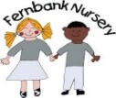Weekly Activities Report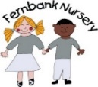
Week commencing- 22/04/2024
All children in nursery will be;
- Joining in with P.E activities in the school hall on a Tuesday morning and Thursday afternoon and gymnastics on a Wednesday morning. Please could children wear suitable shoes on these days to join in with P.E
- Jolly Phonics letter sound ‘R r’. Learning the letter sound, song and finding objects around nursery that start with the letter ‘R r’
- Joining in with show and tell time. Your child can bring something in to show but please only on their key groups day; Monday’s – Blue group
Wednesday’s – Yellow group
Friday’s - Green group
- Story of the week ; ‘Dinosaur rescue’
- Makaton sign of the week;
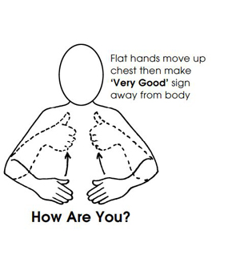
Next week children in their key groups will be: (if you are unsure of your child’s colour group please ask staff) If you do any shared learning at home please upload to evidence me, we would love to see it and add it into your child’s learning journal
Hannah and Narinder’s Yellow group:
- Practicing our scissor control and talking about how we use scissors safely
- Cutting up our own jigsaws and piecing them back together
- For next week’s show and tell please could yellow group children bring in a photograph of someone special to them
- Letters and sounds group activity
Jo Green group:
- Practicing to write our own names and some numerals (Pre-school) Mark making (non- pre-school)
- ‘His’ and ‘her’ comprehension and expression activity
- Gluing and sticking colour matching activity
- Creating patterns and learning about symmetry
Farheen and Humera’s Blue group:
- Practicing to write our own names using our name cards (pre-school) mark making (non-pre-school)
- ‘first and ‘last’ comprehension activity
- Comparing objects according to their size and ordering them from smallest to biggest
Messages to parents;
- Ramadan/Eid performance- Wednesday 24th April 2024 (pre-school children only) Children to be back at nursery for 4.50pm for a 5pm start
- Eid party day – Thursday 25th April 2024. Combined sessions to accommodate for all children
- If any children are starting toilet training or going to the dentist we have some ‘Beanie resource bags’ for you to request. Please ask staff about these resource bags.

